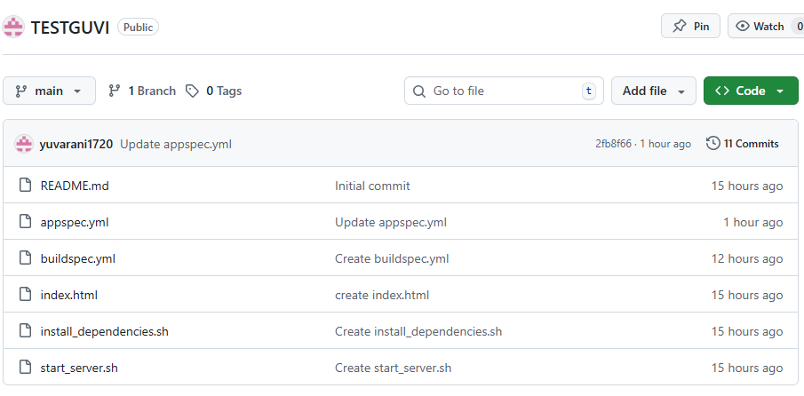

sudo yum update -y

sudo yum install ruby wget -y

cd /home/ec2-user

wget https://aws-codedeploy-<us-east-1>.s3.<us-east-1>.amazonaws.com/latest/install

chmod +x ./install

sudo ./install auto

sudo systemctl start codedeploy-agent



